**The Butterfly Learnings Parent App - A Digital Enabler for Evidence-Based Therapy**

The Butterfly Learnings parent app is designed as a crucial component within a structured, data-driven therapy process for children with behavioral disorders, primarily employing an evidence-based ABA therapy approach. This process flows systematically from "Screening" to "Pre-assessment," "Define therapy," "Deliver therapy," and "Monitor" progress. Butterfly Learnings emphasizes that "data is generated at every step of the process from Pre-assessment to ongoing delivery of therapy", positioning the app as a central tool for data capture, management, and presentation to parents.

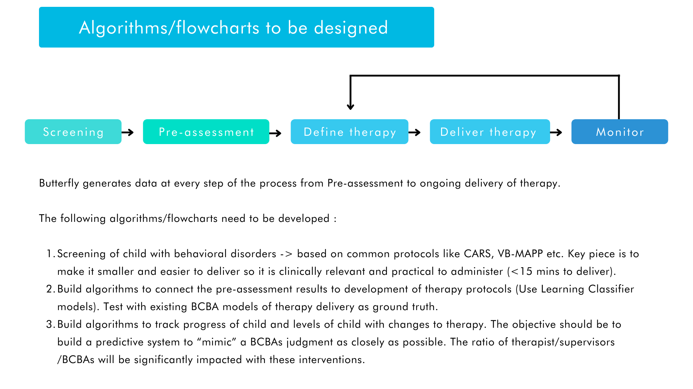

**Core Functional Elements of the Parent App (from App Manual):**

The app provides parents with essential functionalities to manage their child's therapy journey and stay informed:

Onboarding and Account Management:

Sign-Up: New users can easily sign up by clicking a button and entering the required details.

Login: Users can log in using their credentials or leverage Facebook and Google accounts for convenience.

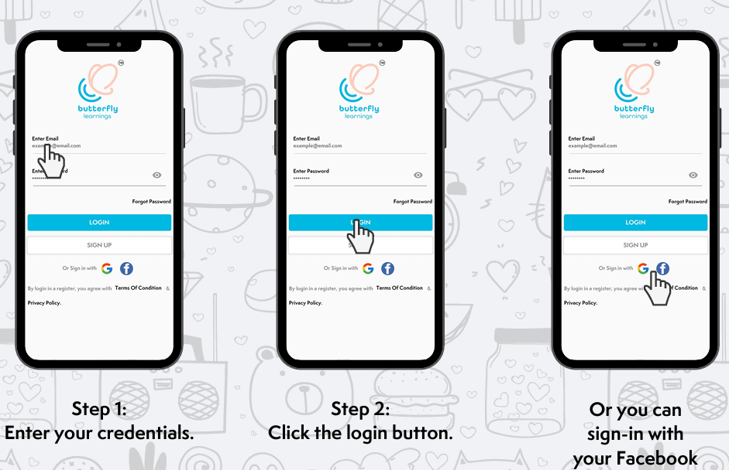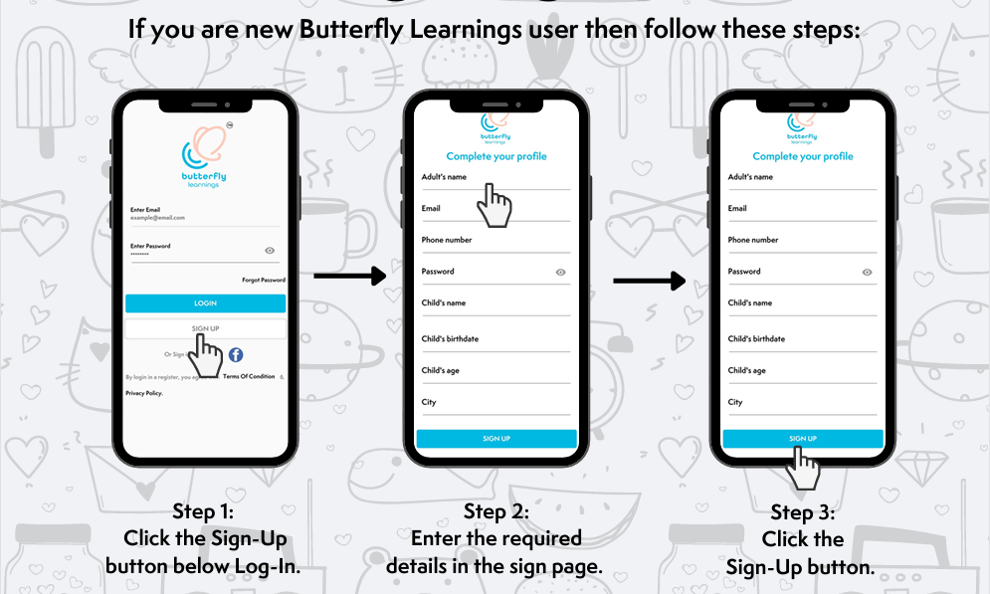

Subscription & Pre-assessment Scheduling: Parents can browse and subscribe to Butterfly Learnings services via the hamburger menu, selecting "Subscription" and "Pay Now". This process includes

Scheduling a pre-assessment by selecting a date and time and confirming the booking.

* **Therapy Management and Direct Engagement:**
* Homepage Overview: The homepage provides a quick view of upcoming sessions (which can be swiped left or right), active programs, and information about the child's "care team".
* Joining Therapy Sessions: Parents can initiate therapy sessions directly from the app by clicking a video button, allowing audio and video recording, and then waiting for the designated therapist to join.
* Communication with Care Team: The app facilitates direct messaging with the care team. Parents can navigate to the home screen, click the message button, select a therapist, and send a message.

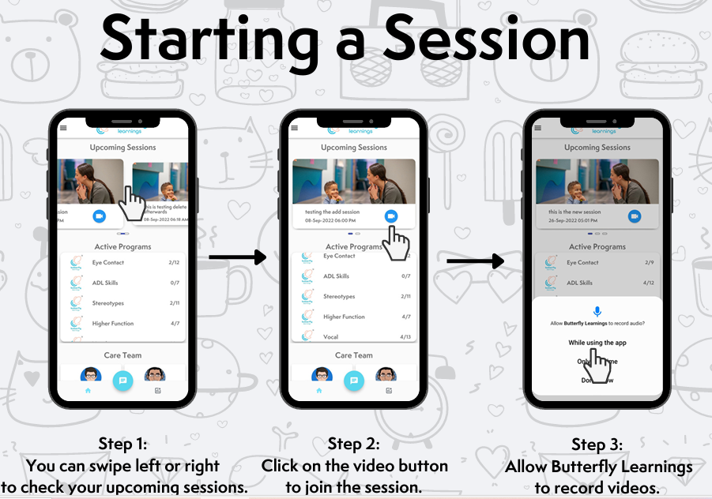

* **Progress Tracking and Data Visualization:**
* Viewing Child's Progress Graphs: A key feature aligning with Butterfly Learnings data-centric approach, parents can view their child's progress graphs and their interpretations. This can be accessed either via a graph icon in the footer or by selecting "Progress" from the hamburger menu. This directly supports the company's objective to "Monitor" progress and build "algorithms to track the progress of the child".

**Algorithmic and Process Design Integration (from Flowcharts):**

* The app's functionalities are designed to support Butterfly Learnings underlying systematic approach to therapy:
* Data Generation: "Butterfly generates data at every step of the process from Pre-assessment to ongoing delivery of therapy". The app's session joining and progress tracking features are integral to this.
* **Algorithmic Development:**
* Algorithms are to be developed for screening children with behavioral disorders, based on common protocols like CARS and VB-MAPP. The key piece is to make it smaller and easier to deliver so it is clinically relevant and practical to administer (less than 15 minutes to deliver).
* Algorithms will connect pre-assessment results to the development of therapy protocols, using Learning Classifier models, and will be validated against existing BCBA models.
* Crucially, algorithms are needed to track the progress of the child and levels of progress with changes to therapy. The objective should be to build a predictive system that "mimics" a BCBA's judgment as closely as possible. The ratio of therapists/supervisors/BCBAs will be significantly impacted by these interventions.

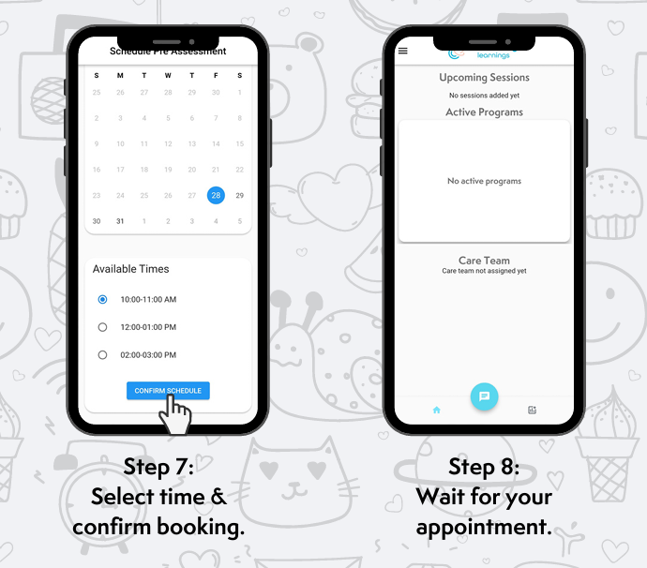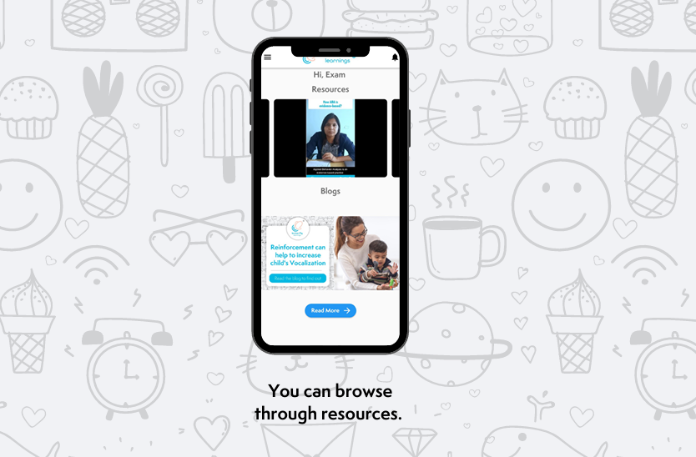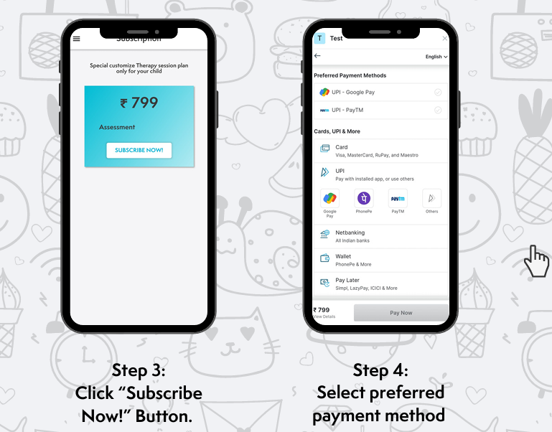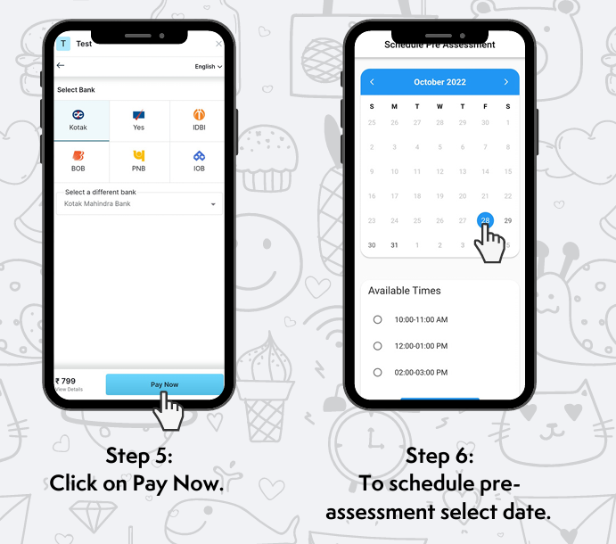

**Result: App Performance and User Experience Analysis (UXCam Statistics):**

**The UXCam data provides critical insights into how the app is performing in the hands of its users, highlighting both usage patterns and areas of friction:**

**Overall Usage Metrics:**

* Sessions: Session counts show significant fluctuations across different periods, ranging from 612 sessions with a -90% change to 487 sessions with a -79% change, and 1.8K sessions with a +44.6% change.
* Active Users: Similarly, active user counts vary, with 231 users showing a -31% change, 147 users showing a +20% change, and a total of 348 users (146 new) showing a -12.6% decrease in new users. A unique user count of 535 was observed with a +27.99% increase over the previous 31 days. These indicate dynamic user engagement, possibly tied to the therapy cycle.
* Average Session Duration: This metric consistently remains low, ranging from approximately 1.1 minutes to 2.0 minutes, with an average often around 1.2 minutes. This could suggest quick task completion or, conversely, rapid disengagement.
* Top App Version: Primarily 1.3.2 or 1.3.34.
* Geographic Focus: The app's usage is overwhelmingly concentrated in India (97%-99%).
* Top Devices: Predominantly Android Large, with specific models like CPH2405, SM-M215F, iPhone 15 Pro, moto g32, SM-M315F, and SM-M127G also being used.
* Top Week Day: Varies between Tuesday (19%) and Saturday (17%).
* Top Screen: "MainActivity" consistently ranks as the top screen by engagement (25%, 46%).

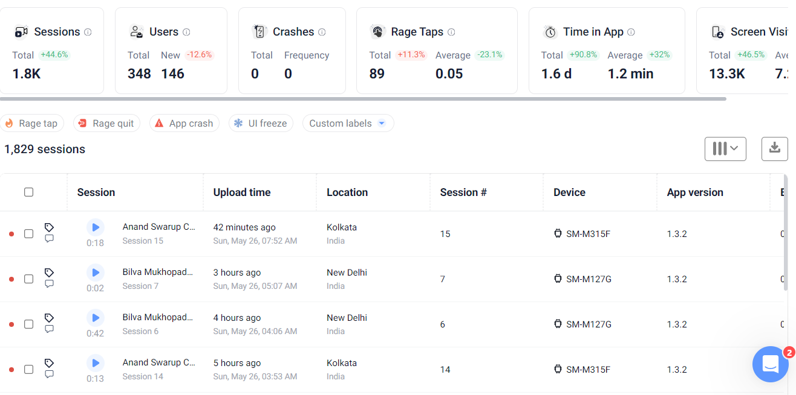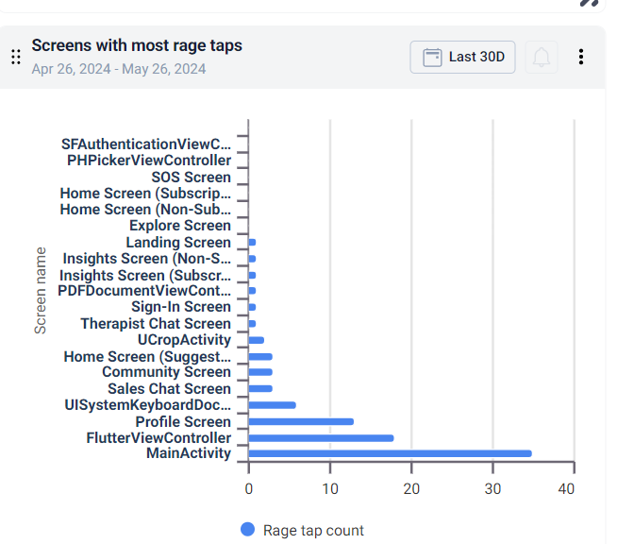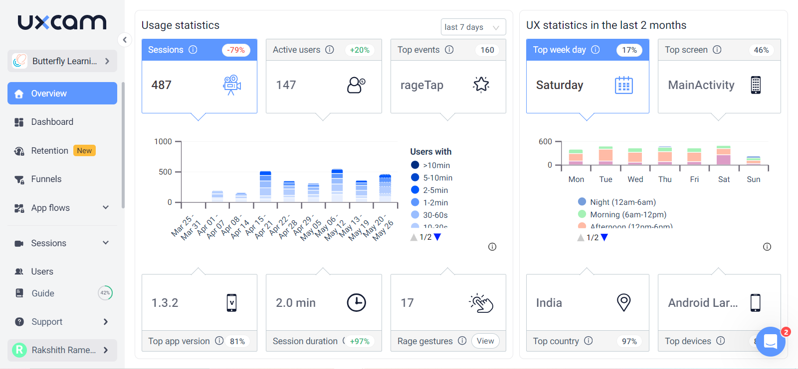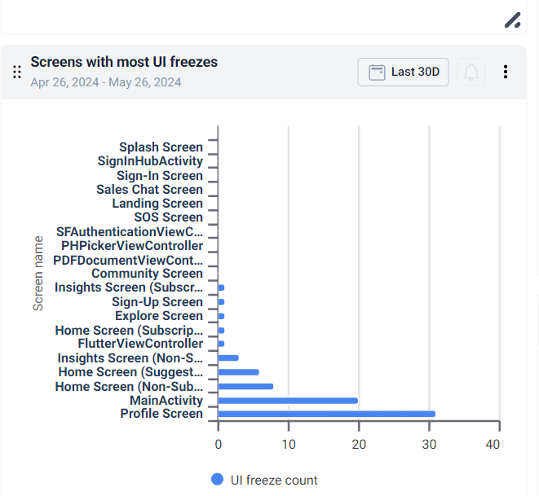

* **Screen-Specific Performance and Friction Points (from UXCam):**
* MainActivity: While having a high visit count (3.04K) and user count (620), it also exhibits a very high app quit rate of 39.89% and a notable rage tap rate of 0.5847%. This suggests that the primary landing screen is a significant source of user frustration or rapid exit.
* Home Screen: Shows 964 visit counts and an app quit rate of 42.74%.
* Home Plans Screen: Appears to be relatively stable with a low app quit rate (8.639%) and 0% rage tap rate despite 926 visits. This screen seems to offer a smoother user experience.
* FlutterViewCont: While users spend a longer average time per user (4.35 min), this screen has an extremely high app quit rate of 65.15% and a discernible rage tap rate (0.259%). Given that "FlutterViewCont" might be associated with core interactive elements or sessions, these metrics are highly concerning.
* UI Freezes: MainActivity and Profile Screen show the highest UI freeze counts. Other screens with notable UI freezes include Sign-In Hub Activity, Landing Screen, SOS Screen, PDFDocumentViewController, Community Screen, Home Screen variations, and Sign-Up Screen. Freezes on onboarding screens like Sign-In Hub Activity and Sign-Up can severely hinder user adoption.
* Rage Taps: MainActivity, FlutterViewCont, and Profile Screen exhibit the highest rage tap counts. Rage taps indicate user frustration and repeated, unsuccessful attempts to interact with an element. Other screens with rage taps include Sign-In Hub Activity, Home Screen (Subscription/Non-Subscription), Community Screen, Sales Chat Screen, and Therapist Chat Screen.
* Crashes: One overview indicates 0 crashes, though other UXCam data points to "crashed session" metrics (without specific numbers for platforms).

**Conclusion: Synthesizing App Functionality with User Experience Realities**

The Butterfly Learnings parent app is clearly designed with a robust set of features that directly align with the company's systematic approach to therapy, from subscription and session management to vital progress tracking. The app's capabilities directly support Butterfly Learnings' commitment to data generation at every step and the development of algorithms to track progress and mimic BCBA judgment, which are foundational to their service.

However, the UXCam data reveals a significant gap between intended functionality and actual user experience. The high incidence of UI freezes and rage taps on critical screens like MainActivity, FlutterViewCont (likely central to session delivery), and Profile Screen indicates severe usability issues that are directly leading to user frustration and disengagement. The consistently low average session duration, combined with high app quit rates (especially on MainActivity, Home Screen, and FlutterViewCont), suggests that users may be struggling to complete tasks or are abandoning the app prematurely due to these friction points. While the app serves its purpose in outlining services and tracking progress, the underlying technical and usability issues undermine its effectiveness as a seamless tool for parental engagement and therapy management.

**Actionable Recommendations:**

**Immediate UX/Technical Deep Dive on Core Screens:**

* Prioritize fixing UI freezes and rage taps on MainActivity, FlutterViewCont, and Profile Screen. These are the most significant pain points impacting central user journeys (app entry, therapy sessions, personal information access).
* Conduct thorou gh technical diagnostics to identify the root causes of these freezes (e.g., inefficient code, heavy asset loading, memory leaks).

**Investigate High App Quit Rates:**

Beyond technical issues, conduct qualitative user research (e.g., user interviews, usability testing sessions recorded via UXCam) to understand *why* users are quitting at high rates from MainActivity, Home Screen, and FlutterViewCont. This could uncover issues like unclear navigation, lack of compelling content, or unfulfilled expectations.

**Optimize Session Experience:**

Focus on the FlutterViewCont screen due to its high app quit rate (65.15%) and rage taps, despite a longer average time per user. This contradictory data suggests that users are spending time but ultimately failing or getting frustrated before quitting. If this screen is vital for therapy sessions, its instability is critical.

**Enhance Onboarding and Initial Experience:**

Address the observed UI freezes and rage taps on the Sign-In Hub Activity and Sign-Up screens to ensure a smooth and frustration-free initial experience for new users, which is crucial for adoption and retention.

**Refine Progress Visualization and Actionability:**

While the app allows viewing graphs, ensure that the "algorithms to track progress" and the "predictive system to 'mimic' a BCBA's judgment" are not only accurately reflected but also presented in a way that is highly intuitive, actionable, and reassuring for parents. Clear interpretations and next steps based on the data should be paramount to reinforce the value proposition of "Guaranteed Progress."

By addressing these critical usability and technical issues, Butterfly Learnings can transform its parent app from a functional tool into a truly seamless and supportive companion for parents navigating their child's therapy journey.